Summit Station Fire Department
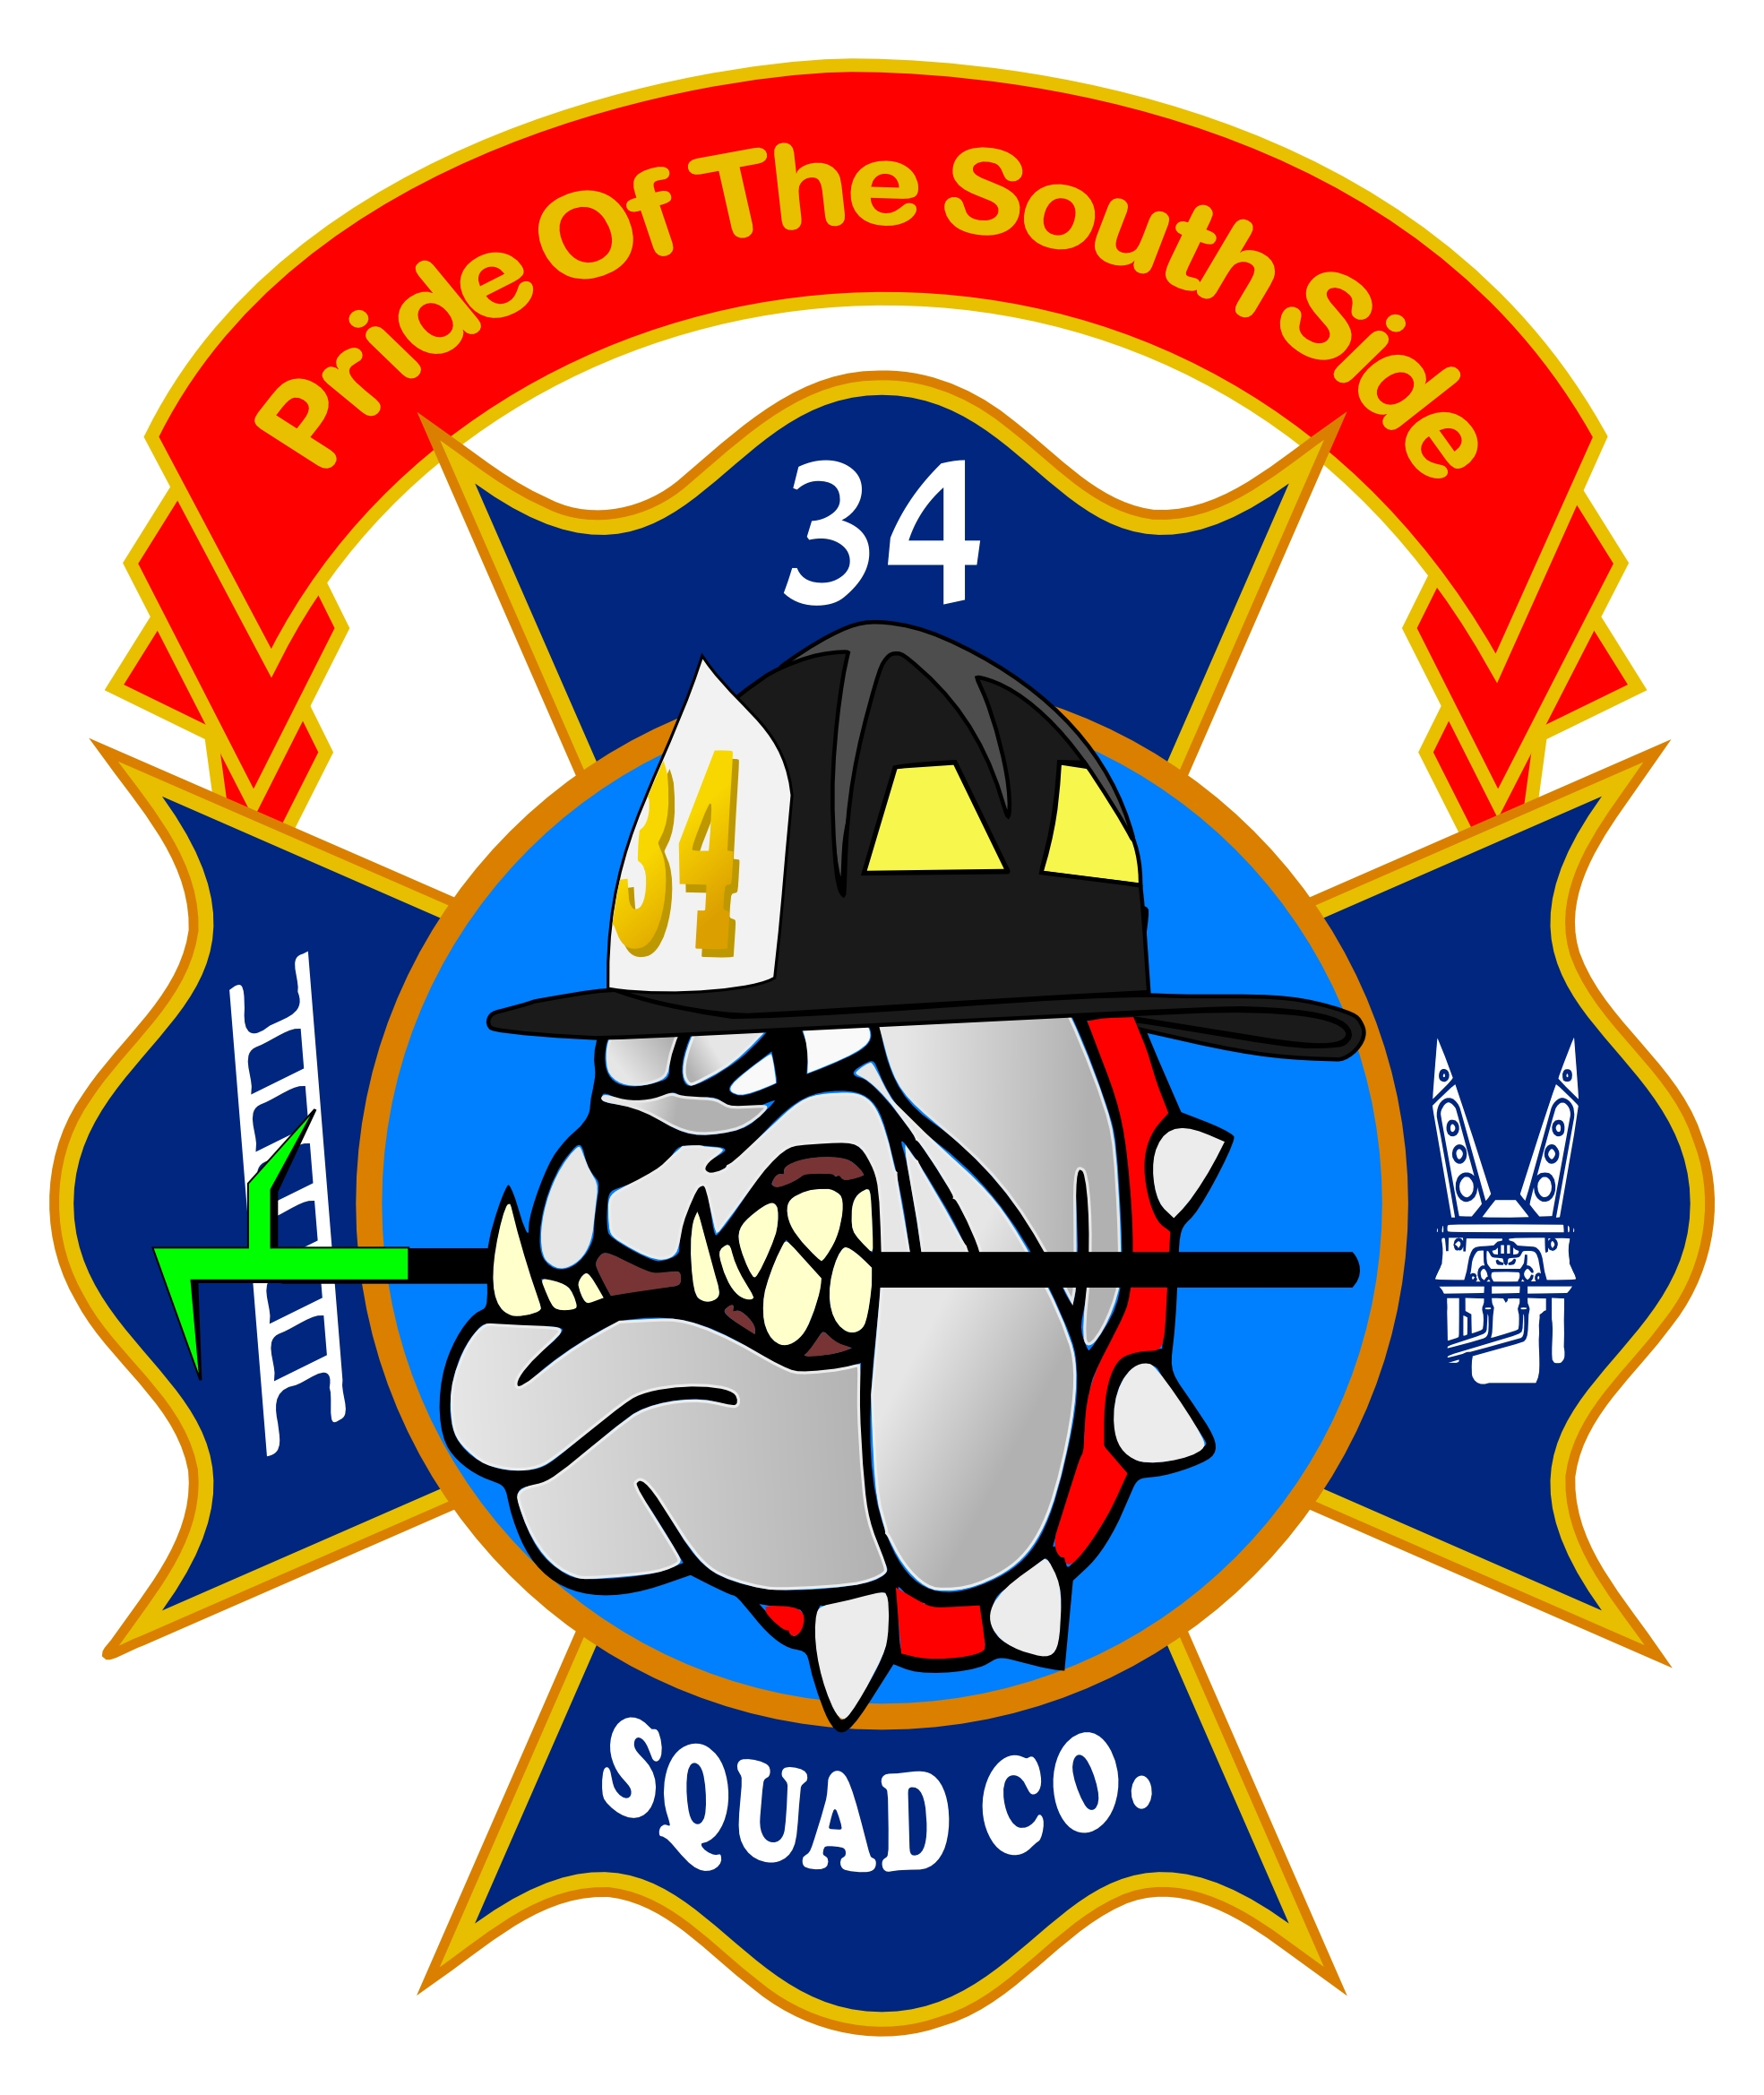

Junior Fire Camp Application

CHILD’S NAME:_____________________________________

ADDRESS: _________________________________________
CITY, STATE, ZIP CODE ______________________________
PHONE NUMBER: ___________________________________
E-MAIL ADDRESS: __________________________________
DATE OF BIRTH: ________________AGE:______________
PARENT/GUARDIAN NAME:________________________
Please circle both sizes below: (Adult)
SHIRT SIZE: SHORTS SIZE:
SMALL SMALL
MEDIUM MEDIUM
LARGE LARGE
X-LARGE X-LARGE
2X-LARGE 2X-LARGE

Persons allowed to pick up my Child: _______________________________________________________________________________________________________
EMERGENCY MEDICAL AUTHORIZATION:
As parent or legal guardian of ___________________________, I furthermore give permission to Summit Station Fire Company and its employees and volunteers to obtain emergency medical treatment for my child(ren) or the child(ren) over whom I have legal custody, each of whom is listed above.
I understand that all reasonable effort will be made to contact me prior to seeking medical car for the child(ren) listed above. If I cannot be reached, the Summit Station Fire Department will exercise reasonable judgment in seeking medical treatment for my child.
Signature: _______________________________ Date:______________
MINOR CHILD RELEASE, LIABILITY WAIVER AND HOLD HARMLESS STATEMENT FOR PARTICIPANTION IN THE FIRE CAMP SPONSORED BY SUMMIT STATION FIRE COMPANY
I understand that there are certain risks involved with participating in the activity identified above. On behalf of my minor child identified below, I hereby RELEASE, DISCHARGE AND AGREE TO HOLD HARMLESS SUMMIT STATION FIRE COMPANY, IT’S OFFICERS, AGENTS, VOLUNTEERS, ASSISTANTS, AND EMPLOYEES, from any and every claim, demand or action of any kind arising due to bodily injury, illness, death and/or property damage resulting from any accident which may occur to my minor child as a result of my minor child’s participation in the activity’s. This RELEASE, LIABILITY WAIVER AND HOLD HARMLESS STATEMENT does not apply if such injury, death or damage is caused by the willful, reckless or gross negligence of Summit Station Fire Company, its officers, agents, volunteers, assistants or employees.

Signature: ________________________________ Date: ____________

Printed Name: _____________________Printed name of minor Child: _________________

PHOTOGRAPH RELEASE
To more effectively promote programs and activities sponsored by Summit Station Fire Company, we seek the permission of program and activity participants to photograph the participants and their child/children. Please complete the following:
I, _______________________, the parent or legal guardian of ___________________________, permit Summit Station Fire Company to take and use photographs of me and/or my child/children for the purpose of promoting the program and activates. I understand that such photographs of me and/ or my child/children remain the property of Summit Station Fire Company.
Signature: ___________________________________ Date: _____________

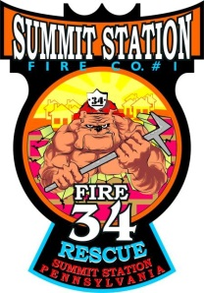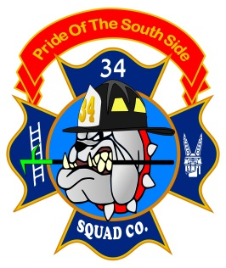
Emergency Information Sheet
Child’s Name:
DOB:
Address:
City:
State:
Zip Code:
Height:
Weight:
Allergies:
Medical Condition:
Medications:
Emergency Contact Name:
Emergency Contact Phone:
Preferred Hospital:
Family Doctor:
Additional medical Information:
Parent’s Signature:

